**Purchasing a New Computer**

By: Hrithik Shah

July 5, 2016

**Student 1 - Adam**

Alienware Laptops -

<http://www.alienware.ca/Landings/laptops.aspx?ST=alienware&dgc=ST&cid=3852&lid=5386516&acd=123088137920560&ven1=sktCvQTBu&ven2=e>

In my opinion, I feel that the perfect computer for Adam would be an Alienware Laptop Alienware Laptops are meant for gamers and multi-taskers like Adam.

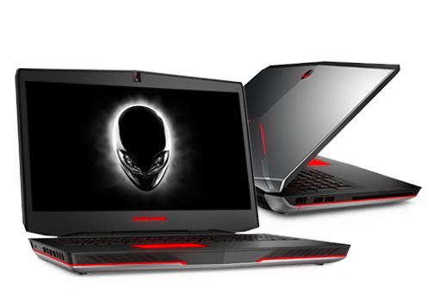

**Manufacturer:** Dell **Model:** Alienware 17

**Total Price:** $2,261.12

|  |  |  |
| --- | --- | --- |
|  |  | |

What Adam wanted was:

* Large Screen (24 in)
* Lots of RAM
* Good Video Card (GTX280)
* Fast Processor (Quad-Core)

What Adam will get from an AlienWare Laptop:

* Large Screen (17.3 inch FHD (1920 x 1080) IPS-Panel Anti-Glare 300-nits Display)
* RAM (16GB Dual Channel DDR4 at 2133MHz)
* Video Card (NVIDIA GeForce GTX 970M with 3GB GDDR5)
* Processor (Intel Core i7-6700HQ (Quad-Core, 6MB Cache, up to 3.5GHz w/ Turbo Boost)
* Hard Drive (1TB 7200RPM SATA 6Gb/s)
* Operating System (Windows 10 Home 64bit English)
* DVD/CD Drive: Yes
* Microsoft Office 30 Day Trial
* 1 Year Warranty
* 10.5 hr of Battery Life

The Alienware laptop is the ideal match for Adam, as it takes into account all his needs. Although the screen is smaller than his old computer, the quality of the image produced by the screen is completely different. With Alienware Adam can play his games in 4K. Furthermore, the laptop provides a very efficient processor, one of the best in the world. Even the video card is specially designed to suit the needs of gamers such as Adam. The 16 GB of RAM will help Adam multitask like a pro.

**Student 2 - Brittany**

Macbook Air -

<http://www.apple.com/ca/macbook-air/>

The Macbook Air is a great computer for Brittany as it is great for surfing the web, working on presentations and storing/listening to music.

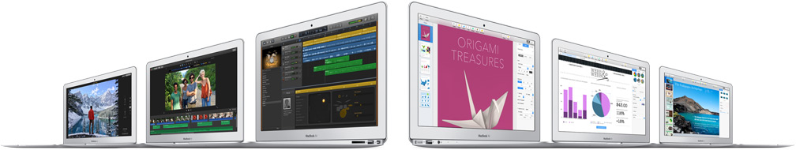

**Manufacturer:** Apple **Model:** Macbook Air 11-inch

**Total Price:** $1,241.87

Specifications:

* Processor (1.6-GHz Intel Core i5-5250U)
* RAM (4GB)
* Solid State Drive (128 GB)
* Video Card (Intel HD Graphics 6000)
* 11.6-inch (diagonal) LED-backlit display
* 10 hours of Battery life while playing music from iTunes
* 9 hours of Battery life while surfing the web
* Operating System (OS X El Capitan)
* CD/DVD Drive: No
* 1 Year Warranty

This is a great computer for Brittany as it will serve all her needs. She can attain countless hours of listening to music and surfing the web. In addition, the computer has the processing power needed to make presentations and documents. As a high school student, Brittany would be able to take her computer to school, and so portability would be necessary for the computer. Macbook Air’s are one of lightest and most portable computers in the world, and they are ideal for a student in highschool or university. Therefore, the laptop will be useful to her in the future as well.